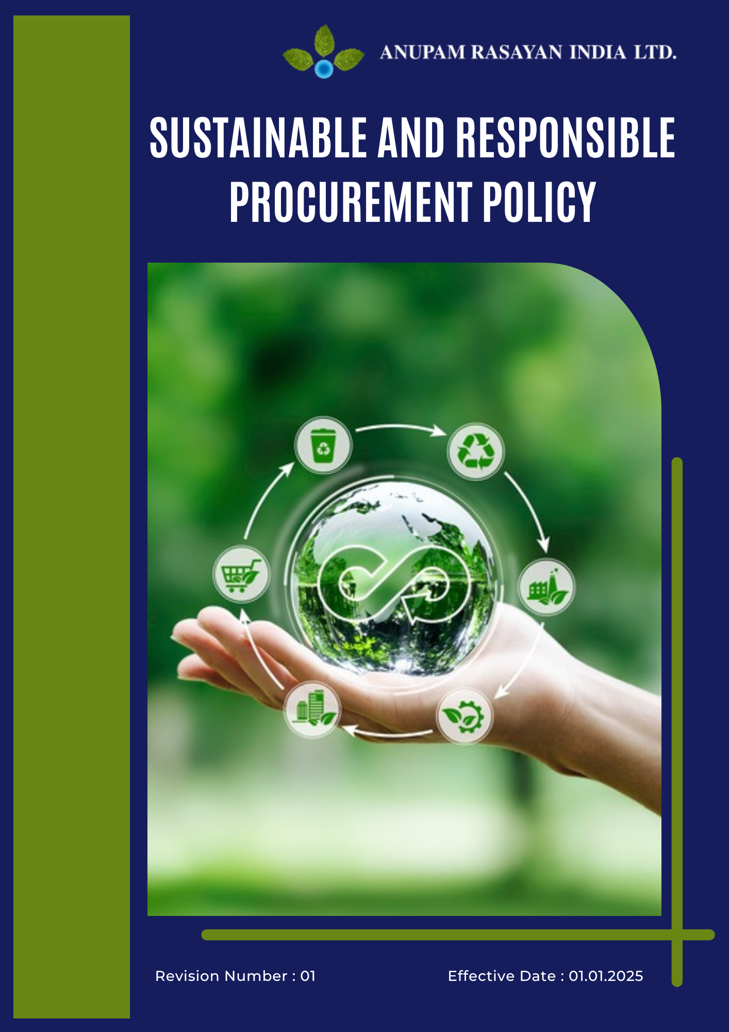

Table of Contents

➢ Introduction: 3
➢ Scope: 3
➢ Procurement Commitments: 4
➢ Quantitative Targets: 4
➢ General Sustainable Procurement Targets: 6
➢ Action Framework: 6
➢ Roles and Responsibilities: 7
➢ Monitoring and Reporting: 9
➢ Review: 9
➢ Employee Acknowledgement- Anupam Rasayan Sustainable and Responsible Procurement Policy 11

Introduction:
Anupam Rasayan India Limited (ARIL), established in 1984, is committed to promoting sustainability and responsibility across its supply chain. Through this Sustainable and Responsible Procurement Policy, we aim to ensure that all goods and services are sourced ethically, transparently, and with minimal environmental and social impact.
We work collaboratively with our suppliers and business partners to uphold principles of fair trade, human rights, safety, and environmental stewardship, in line with the UN Global Compact, ISO 20400 Sustainable Procurement Guidelines, and BRSR requirements.
This policy reflects ARIL’s belief that responsible procurement strengthens long-term partnerships, supports local communities, and contributes to a more sustainable future.

Scope:
This Sustainable and Responsible Procurement Policy applies to all Anupam Rasayan India Limited (ARIL) facilities, employees, contractors, and suppliers involved in procurement, logistics, and supply chain operations.
It covers the sourcing of raw materials, packaging materials, equipment, and services across all manufacturing units, R&D facilities, and administrative offices.
The policy extends to vendors, business partners, and third-party service providers, ensuring that all procurement activities are aligned with ARIL’s principles of ethical conduct, environmental responsibility, human rights, and fair labor practices.
Site Coverage
Location | Address | Primary Function
Sachin Unit 1 | Plot No. 8109, 8110, 8111, 268/1, GIDC Sachin, Surat, Gujarat – 394230 | Manufacturing Site
Sachin Unit 2 | Plot No. 701, 2419/1, 2419/2, GIDC Sachin, Surat, Gujarat – 394230 | Manufacturing Site
Sachin Unit 3 | Plot No. 8104 and 8106, GIDC Sachin, Surat, Gujarat – 394230 | Manufacturing Site
Sachin Unit 6 | Plot No. 2423 and 2425, GIDC Sachin, Surat, Gujarat – 394230 | R&D and Manufacturing
Jhagadia Unit 4 | Plot No. 907/3, 907/4, GIDC Jhagadia, Bharuch, Gujarat – 393110 | Manufacturing Site
Jhagadia Unit 5 | Plot No. 905/1, GIDC Jhagadia, Bharuch, Gujarat – 393110 | Manufacturing Site
Tanfac Industries Limited | Plot No. 14, SIPCOT Industrial Complex, Kudikadu, Cuddalore – 607005, Tamil Nadu | Fluorochemical Manufacturing

Procurement Commitments:
Anupam Rasayan is committed to ensuring that its procurement practices support sustainability, ethical conduct, and social responsibility across the value chain. We aim to partner with suppliers who share our commitment to environmental protection, fair labor practices, and business integrity. Our procurement commitments are defined under the following key focus areas:
- Ethical Sourcing: We ensure that all products and services are procured transparently and in compliance with applicable laws, ethical standards, and anti-corruption principles. Suppliers are expected to operate with integrity, avoiding bribery, fraud, and unfair trade practices in all transactions.
- Environmental Responsibility: Suppliers must minimize their environmental footprint by adopting sustainable production methods, waste reduction measures, and energy-efficient processes. Preference is given to suppliers that use eco-friendly materials, manage waste responsibly, and work toward carbon reduction.
- Labor and Human Rights Standards: All suppliers are required to uphold internationally recognized human rights and fair labor practices. Forced labor, child labor, unsafe working conditions, or any form of discrimination are strictly prohibited within our supply chain.
- Health and Safety: Suppliers must maintain a safe and healthy workplace by following relevant safety laws and implementing occupational health programs. ARIL encourages continuous improvement in safety standards across the supply chain.
- Local and Inclusive Procurement: We promote local sourcing and inclusion of small, medium, and diverse suppliers where feasible, contributing to regional economic development and community growth.
- Supply Chain Transparency: We expect suppliers to provide accurate, traceable information about materials, sourcing practices, and environmental or social impacts. Regular audits and performance evaluations are conducted to ensure compliance with ARIL’s sustainability standards.

Quantitative Targets:
Sets 2022 as the baseline for tracking progress in sustainable procurement, supplier responsibility, and ethical sourcing across all operations and supply chain partners.

- Ethical Sourcing
- Ensure 100% of suppliers and contractors comply with ARIL’s Code of Conduct and ethical business requirements by 2027.
- Conduct annual anti-corruption and compliance training for 100% of procurement and supply chain teams by 2026.
- Perform ethical due diligence assessments for 100% of high-risk suppliers by 2027.
- Achieve zero tolerance for corruption, bribery, or unethical practices in all procurement transactions.

- Environmental Responsibility:
- Conduct sustainability and environmental risk assessments for 100% of critical suppliers by 2027.
- Ensure that at least 30% of suppliers adopt measurable environmental management programs (energy, waste, or water reduction) by 2027.
- Prioritize suppliers using eco-friendly packaging and recyclable materials in 20% of procurement by 2027.
- Achieve zero non-compliance cases with environmental laws or supplier sustainability requirements.

- Labor and Human Rights Standards:
- Achieve 100% supplier compliance with labor and human rights criteria by 2027, including prohibition of child and forced labor.
- Conduct social and ethical audits for 100% of Tier-1 suppliers by 2027.
- Train 100% of procurement officers and vendor managers on human rights and labor due diligence by 2026.
- Report zero instances of supplier-related human rights violations each year.

- Health and Safety:
- Conduct annual health and safety compliance audits for 100% of critical suppliers by 2027.
- Achieve 100% supplier awareness of ARIL’s EHS (Environment, Health & Safety) requirements by 2026.
- Integrate safety performance evaluation into all supplier selection and renewal processes by 2027.
- Maintain zero serious injury or fatality cases reported within the supplier network.

- Local and Inclusive Procurement:
- Increase local and regional sourcing by 90% by 2027 to strengthen community engagement and reduce logistics emissions.
- Engage at least 90% of total suppliers from small, medium, or women-owned enterprises by 2027.
- Host annual supplier development programs to build sustainability capacity among local vendors.
- Ensure 100% payment transparency and fair terms for all local suppliers.

- Supply Chain Transparency:
- Implement a Supplier Sustainability Evaluation System covering 100% of suppliers by 2027.
- Ensure 100% traceability of critical raw materials to verified and responsible sources by 2027.
- Publish annual supplier sustainability performance data in the Sustainability Report starting FY2025–26.
- Conduct supplier risk assessments for all new vendors before onboarding.

General Sustainable Procurement Targets:

Anupam Rasayan India Limited (ARIL) is committed to continuously strengthening sustainability performance across its procurement and supply chain operations. Beyond specific focus-area targets, ARIL has established the following general sustainable procurement objectives to be achieved by 2027, using 2022 as the baseline year:
- Conduct ESG on-site audits at 100% of operational sites and critical supplier locations by 2027, ensuring comprehensive evaluation of environmental, social, and governance performance.
- Deliver annual ESG and sustainability awareness training covering at least 20% of active suppliers by 2027, with progressive increase in coverage each year.
- Integrate sustainability performance criteria (covering environmental, labor, ethics, and safety aspects) into 100% of new supplier selection and contract renewals by 2027.
- Ensure 100% of procurement employees and decision-makers complete sustainability and responsible sourcing training by 2026.
- Increase procurement from sustainable and eco-certified suppliers by at least 25% by 2027, prioritizing those demonstrating measurable ESG improvements.
- Conduct bi-annual supplier ESG performance reviews and report progress through the annual Sustainability Report.

Action Framework:
To implement these commitments effectively, Anupam Rasayan will:
- Integrate sustainability and ethical criteria into all stages of the procurement process — from supplier selection and evaluation to contract management and performance reviews.
- Develop and maintain a Supplier Code of Conduct outlining ARIL’s expectations regarding ethics, labor rights, health and safety, and environmental performance.
- Conduct supplier risk assessments for environmental, social, and governance (ESG) factors across 100% of critical suppliers by 2027, ensuring proactive identification and mitigation of supply chain risks.
- Establish a Supplier Sustainability Evaluation System to monitor supplier performance through periodic audits, self-assessments, and on-site inspections.
- Provide training and capacity-building programs for suppliers and procurement teams on sustainability practices, human rights, and business ethics.
- Encourage suppliers to adopt recognized management systems such as ISO 14001 (Environment), ISO 45001 (Health & Safety), and ISO 37001 (Anti-Bribery) to strengthen compliance and performance consistency.
- Promote local and inclusive procurement to support small and medium enterprises (SMEs), women-led businesses, and regional vendors contributing to community development.
- Collaborate with suppliers to reduce carbon emissions, optimize material use, and minimize waste, supporting ARIL’s broader climate and environmental goals.
- Implement a supplier grievance and feedback mechanism to ensure transparent communication, quick issue resolution, and continuous improvement in supplier relationships.
- Review and update procurement practices periodically based on evolving sustainability standards, stakeholder feedback, and audit outcomes to ensure alignment with ARIL’s ESG commitments.

Roles and Responsibilities:

Stakeholder | Key Responsibilities
Board of Directors & Sustainability Committee | - Approve and oversee the implementation of the Sustainable and Responsible Procurement Policy across all business units.  - Review annual procurement performance reports, supplier audits, and compliance results.  - Ensure that procurement decisions align with ARIL’s long-term sustainability and ESG strategy.  - Allocate adequate resources for supplier evaluation, risk management, and sustainability initiatives.
Managing Director & Unit Heads | - Lead implementation of responsible procurement practices at all sites.  - Ensure adherence to sustainability, ethical, and social standards in procurement operations.  - Monitor supplier performance and escalate significant compliance issues to the Sustainability Committee.  - Promote supplier engagement and collaboration for continuous improvement.
Procurement & Supply Chain Team | - Integrate sustainability, ethics, and compliance criteria into all procurement processes.  - Conduct supplier due diligence and ESG risk assessments before vendor onboarding.  - Maintain supplier documentation and performance evaluation records.  - Ensure transparent bidding, fair selection, and zero tolerance for corruption or favoritism.  - Encourage suppliers to adopt sustainable practices and relevant certifications.
Ethics & Compliance Committee | - • Oversee supplier ethics compliance, including anti-bribery, anti-corruption, and fair labor standards.  - Conduct internal and third-party audits to verify supplier adherence to ARIL’s Code of Conduct.  - Manage supplier grievances and corrective action plans.  - Report significant ethical violations or non-compliance cases to senior management.
Sustainability & EHS Department | - Evaluate environmental and social risks in supplier operations.  - Conduct sustainability and safety audits for high-impact suppliers.  - Support suppliers in improving their environmental management and health & safety performance.  - Align supplier practices with ARIL’s broader sustainability goals, including carbon reduction and waste minimization.
Finance & Audit Department | - Ensure transparency and accountability in procurement-related payments, contracts, and transactions.  - Verify supplier financial stability and compliance with anti–money laundering standards.  - Conduct periodic audits to identify and mitigate procurement-related risks.
Training & Development Team | - Design and deliver capacity-building programs for procurement teams and suppliers.  - Promote awareness on ethical sourcing, human rights, and sustainability standards.  - Track and evaluate participation and effectiveness of training initiatives.
Suppliers & Business Partners | - Comply with ARIL’s Sustainable Procurement Policy, Code of Conduct, and applicable laws.  - Maintain transparency in operations, recordkeeping, and reporting.  - Participate in audits, training sessions, and sustainability improvement programs.  - Promptly report any non-compliance or ethical concerns through official channels.
Employees & Contractors | - Adhere to responsible procurement procedures and supplier selection criteria.  - Report unethical practices, favoritism, or supplier non-compliance to the Ethics & Compliance Committee.  - Support continuous improvement in procurement efficiency and sustainability.

Monitoring and Reporting:
1. Procurement Performance Monitoring
- Track key supplier performance indicators (KPIs) such as sustainability compliance, ethical sourcing, audit results, and supplier diversity ratio.
- Conduct annual supplier risk assessments and ESG audits across 100% of critical suppliers by 2027.
- Review supplier corrective action plans and ensure closure of identified non-compliances within defined timelines.
- Monitor procurement practices to ensure adherence to ARIL’s Code of Conduct, sustainability standards, and legal requirements.
2. Reporting Framework
- Disclose procurement-related sustainability performance annually through the Sustainability Report, aligned with GRI 204 (Procurement Practices), GRI 308 (Supplier Environmental Assessment), and GRI 414 (Supplier Social Assessment).
- Present quarterly updates on supplier audit outcomes, compliance metrics, and improvement actions to the Sustainability Committee and Board of Directors.
- Maintain transparent communication with suppliers and stakeholders through progress updates, workshops, and capacity-building sessions.
3. Compliance and Auditing
- Ensure full compliance with ISO 20400 Sustainable Procurement Guidelines, BRSR Principle 5, and relevant environmental, labor, and ethical trade laws.
- Engage independent third-party auditors periodically to verify supplier performance and adherence to ARIL’s procurement standards.
- Document all supplier assessments, audit findings, and improvement actions for review during annual policy evaluation and ESG reporting.

Review:
The Sustainability Committee, in coordination with the Procurement Department, Ethics and Compliance Committee, and EHS Team, shall be responsible for conducting the annual review of this Sustainable and Responsible Procurement Policy.
The review will assess the policy’s effectiveness, supplier performance outcomes, progress on sustainability targets, and alignment with current laws, global standards, and organizational objectives.
It will also evaluate supplier risk assessment results, audit findings, and corrective actions implemented during the reporting period.
Any updates or revisions arising from operational changes, new regulations, audit feedback, or stakeholder inputs will be submitted to the Board of Directors for approval. Once approved, the revised policy will be communicated to all relevant employees, suppliers, and business partners to ensure continued alignment with Anupam Rasayan’s sustainable procurement goals and ESG commitments.

Approved By:

Designation:

Last Review Date: 01/04/2025 Next Review Date: 01/04/2026

Employee Acknowledgement- Anupam Rasayan Sustainable and Responsible Procurement Policy

I acknowledge that I have received, read, and understood the Anupam Rasayan Sustainable and Responsible Procurement Policy.
I am aware of the company’s commitment to integrating sustainability, ethical conduct, and social responsibility into all procurement and supply chain operations.
I understand my role in ensuring that every procurement activity supports responsible sourcing, fair labor practices, transparency, and environmental stewardship.
I agree to follow all related procedures, participate in training programs, and immediately report any unethical or non-compliant behavior related to procurement activities.
By signing below, I confirm my commitment to uphold the Sustainable and Responsible Procurement Policy and contribute to Anupam Rasayan’s goal of building a responsible, transparent, and sustainable value chain.

Employee Name:

Employee Signature:

Date:

